IOAI 2025 Individual Contest Day 2
Team Leader's Translation Version

Team Leaders must complete the form below, even if they don’t need translated documents.
Country Or Region | Saudi Arabia
Number of Team Members  （sample papers will be duplicated according to the number） | 4
How many pages in total  (cover pages included) | 16

Changes in Bohrium
- On day 2, the GPT-4 context window is limited to 1000 tokens (not 4000).
- For each contestant and each task, three submissions will be considered: The $n$ submissions that the participant selects and the $(3-n)$ highest submissions that score highest on Leaderboard A (validation data). Note that you can select $0$, $1$ or $2$ submission, but once you make any selection the system will not allow you to go back to 0.
- Any submission that runs for more than 40 minutes during evaluation, will be killed. This time limit applies to the run time, not how long a submission can stay in the queue.
- Each contestant can submit up to 3 concurrent solutions to a task and only 1 of them will be run at a time.
- The evaluation server is equipped with a total of 480 GPU resources. It is normal to experience a queue. The waiting time is probably be more than 30 minutes when submitting solutions during the final hours. Anyway, we will wait for all the submission to run before calculating the score.
التغييرات في نظام التقييم بوريوم:
- في اليوم الثاني، حجم Context window لنظام GPT-04 سيتم تقليصه من 4000 tokens الى 1000 token فقط
- سيتم اختيار ثلاثة submissions فقط لرصد الدرجة ويتم اختيارها كما يلي: يستطيع المتسابق في كل سؤال ان يحدد عدد $n$ بحد أعلى 3 من الحلول التي يجب على النظام إختيارها وسوف يقوم النظام بشكل آلي اختيار $\left(3-n\right)$ submissions والتي حصلت على أعلى الدرجات في Leaderboard A لتكملية العدد والتي تمت تجربته على validation data فقط. يرجى ملاحظة بأنه يمكنك اختيار 0 أو 1 أو 2 من الحلول التي تم تسليمها فقط وإذا تم اختيار أكثر من حل فلن يسمح النظام التراجع عن جميع الحلول ويكون الحد الأدرنى للتراجع هو حل 1 فقط والحلول الأخرى تحتار بشكل تلقائي.
- بشكل عام أي حل يأخذ أكثر من 40 دقيقة سيتم ايقافه تلقائيا (Killed) علمًا بأن الوقت الذي يقضيه التاسك في queue لن يتم احتسابه من هذا الوقت.
- يحق لكل متسابق رفع 3 حلول في آن واحد وعملية run سوف تكون لكل واحد على حده بالتسلسل.
- المحكم لدية 480 جي بي يو ومن المتوقع حدوث تأخير في Queue والوقت المتوقع للانتظار سيكون حوالي النصف ساعة من وقت التسليم. ولكن الدرجة سوف تحسب كما ذكر في بند رقم اثنان بعد تصحيح و running جميع الحلول المسلمة.

IOAI2025 On-Site Stage: Restroom Icon Matching

Note: Please "join" the competition first. Then, you can mount the dataset to the GPU. Otherwise, the notebook may encounter an error because it cannot access the dataset until you have joined the competition.

1. Problem Description
This task focuses on training a model to learn the relationship between male and female restroom icons from the same restroom. Based on labeled training data, you are required to train a matching model that, given a query image, finds its cross-gender counterpart (e.g., match a male icon in its cropped image to its female counterpart in its original image), under the constraint that both icons come from the same restroom.
For example, for a query image (i.e., a male icon in cropped image) shown below in Fig1, its corresponding counterpart is shown in Fig2 (i.e., a female icon in original image which is from the same restroom).
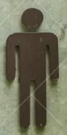 | 

2. Dataset
(1) Training Set:
Used for model training. Directory structure:
train/
├── crop/ # Cropped icons
│ ├── female/ 1.png, 2.png, ...
│ └── male/
└── orig/ # Original icons
├── female/
└── male/
Each subfolder contains icons named from 1.png to 82.png, where the number indicates the restroom ID. For each restroom, there are four images (note that four images from the same restroom will share one same unique id across all four subfolders):
- crop/female/i.png → Cropped female icon
- crop/male/i.png → Cropped male icon
- orig/female/i.png → Original female icon
- orig/male/i.png → Original male icon
(2) Validation Set and Test Set:
Either the validation set (test_a) or the test set (test_b) contains two subfolders:
test_a/ (or test_b/)
├── query/ # Cropped icons to be matched
└── gallery/ # Candidate original icons
- query/: cropped icons that need to be matched.
- gallery/: pool of original icons to match from.
- Note that:
  - Unlike the training split, the filenames in query/ and gallery/ are independently numbered and shuffled, which means that matching cannot rely on the ids
  - For each cropped icon in query/ there are exactly two originals in gallery/ (one male, one female from the same restroom), which means $\text{len}(\text{gallery})=2*\text{len}(\text{que}\text{ry})$
- All images are in .png format.
- The validation set has $10$ images in its query/ folder, and the test set has $30$ images in its query/ folder.

3. Task
For each image in the query/ folder, predict the image in gallery/ that:
- Is of the opposite gender, and
- Comes from the same restroom
This matching should be accomplished using your trained model.

4. Submission
You must submit a notebook named submission.ipynb, which should include:
- Model training process (using train/ data)
- Matching process for both test sets (test_a/ and test_b/)
- The notebook must output two .npy files:
submission_a.npy # Matching results for validation set (test_a).
submission_b.npy # Matching results for test set (test_b).
Each .npy file is a one-dimensional array with a size equal to the number of queries, and each value in the array corresponds to the image ID in the gallery.
For example, one valid submission_a.npy may looks like this:
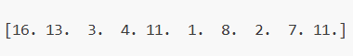
You can also find an example output format in baseline.ipynb.

5. Score
- If the submission finishes within the time limit, the score is calculated as:
$$\text{Score}=\frac{\text{Number of correct matches}}{\text{Total queries}} \text{(1)}$$
- which will be a float number between $0.0$ and $1.0$ (inclusive).
- Submissions that exceed the time limit will receive a score of 0.

6. Baseline and Training Set
- The baseline is in baseline.ipynb.
- The dataset is in training set.

7. Requirements
- Maximum submission limit: 15 times. Only successful submissions (i.e., those receive a score on Leaderboard A) will be counted toward the submission limit.
- Testing environment restrictions: The test machine will run your Notebook within 15 minutes. If the execution time exceeds 15 minutes, the system will forcibly terminate and return a feedback of “timeout” or “Failed”.
- Data and model submission: In this task, participants can only submit a Notebook and cannot submit any mounted datasets or .pth files generated by themselves. Please check the upper right corner to remove the mounted dataset first.
- 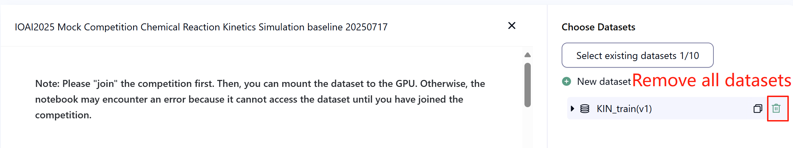
- Network: For the on-site stage, the test machine cannot connect to the internet. In other words, downloading commands such as 'pip' and 'conda' or trying to call APIs will not work.
- Pretrained Model: In this task, we only provide a Clip model in the dataset. You can use it as in baseline.ipynb. Any other pre-trained model can be used in this task when it can be imported properly without network connection and downloading. This message means the Bohrium cannot guarantee to exclude all the pretrained model in the Python image when install the packages, when you find some useful ones, you can use them.

8. Precautions
- Which score is effective: Contestants can select up to 2 submission results for scoring (√ - selected， □ - not selected). The score before unification for this task will be determined by the higher score on the Leaderboard B among the two selected submissions. Other cases of score calculation: please refer to Appendix Platform Mechanisms and Restrictions for Individual Contest & GAITE.
- 
- How to deal with ambiguity: Once there is a conflict between the task description and the training set, the validation set and test set , the dataset will be respected first, and the dataset will not be changed during the competition.
- Contestants can only access Leaderboard A during the contest and cannot access Leaderboard B. The final score will be calculated only based on the score in Leaderboard B.
- The highest score by the Scientific Committee for this task is $0.90$ in Leaderboard B, this score is used for score unification.
- The baseline score by the Scientific Committee for this task is $0.77$ in Leaderboard B, this score is used for score unification.

IOAI2025 On-Site Stage: Antique Painting Authentication

Note: Please "join" the competition first. Then, you can mount the dataset to the GPU. Otherwise, the notebook may encounter an error because it cannot access the dataset until you have joined the competition.

1. Problem Description
You have studied Artificial Intelligence for quite some time. Old friend of your father, famous archeologist and art critic, heard about this and asked for your help. You need to design an algorithm that can classify antique paintings as either authentic or replica pieces.
Because professional authentication is expensive, the research team has only obtained authenticity labels for a small portion of the paintings. For the majority of samples, the authenticity remains unknown. It is known that the paintings' digital features exhibit strong structural patterns. You are tasked with leveraging all available samples — including those with unknown labels — to train a model for classifying the authenticity of antique paintings.

2. Dataset
The dataset consists of a training set, a validation set and a test set, each of them has 500 independent samples.
- Training Set (training_set.csv):
  - The first five columns represent the digital features of each antique painting.
  - The sixth column contains the label: 1 for authentic, -1 for replica, and 0 for unknown.
- The training set is used for training your models and can be accessed and downloaded directly during the competition.
- Validation Set (validation_set.csv):
  - These are similar to the training set format but do not contain the label column.
- The validation set is used to calculate the Leaderboard A score and is not directly accessible during the competition.
- Test Set (test_set.csv):
  - These are similar to the training set format but do not contain the label column.
- The test set is used to calculate the Leaderboard B score and is not directly accessible during the competition.

3. Task
Your task is to train an appropriate model capable of predicting the authenticity of paintings in the test sets, despite the large number of unlabeled samples.

4. Submission
Contestants need to submit a notebook file named submission.ipynb. The file should output a zip file named submission.zip, which should contain the following two files:
- submissionA.csv: Contains the model's predicted label results on the validation set, with each line being a -1 or 1 and no header.
- submissionB.csv: Contains the model's predicted label results on the test set, with each line being a -1 or 1 and no header.
The testing machine will read submission.zip and calculate the scores. The submission files must strictly follow the above format and naming; otherwise, the system will not be able to read them correctly.
Details about the submission procedure are provided in the baseline notebook. Contestants are encouraged to refer to it for guidance.

5. Score
The evaluation metric will be classification accuracy, defined as the proportion of correctly predicted samples over the total number of evaluated samples.

6. Baseline and Training Set
- The baseline is in baseline.ipynb.
- The dataset is in training set.

7. Requirements
- Maximum submission limit: 15 times. Only successful submissions (i.e., those receive a score on Leaderboard A) will be counted toward the submission limit.
- Testing environment restrictions: The test machine will run your Notebook within 10 minutes. If the execution time exceeds 10 minutes, the system will forcibly terminate and return a feedback of “Timeout” or “Failed”.
- Data and model submission: In this task, contestants can only submit a Notebook and cannot submit any mounted datasets or .pth files generated by themselves. Please check the upright corner to remove the mounted dataset first.
- 
- Network: For the on-site stage, the test machine cannot connect to the internet. In other words, downloading commands such as 'pip' and 'conda' or trying to call APIs will not work.
- Pretrained Model: Any pre-trained model can be used in this task when it can be imported properly without network connection and downloading. This message means the Bohrium cannot guarantee to exclude all the pretrained model in the Python image when installing the packages, when you find some useful ones, you can use them.

8. Precautions
- Which score is effective: Contestants can select up to 2 submission results for scoring (√ - selected， □ - not selected). The score before unification for this task will be determined by the higher score on the Leaderboard B among the two selected submissions. Other cases of score calculation: please refer to Appendix Platform Mechanisms and Restrictions for Individual Contest & GAITE.
- 
- How to deal with ambiguity: Once there is a conflict between the task description and the training set, the validation set and test set , the dataset will be respected first, and the dataset will not be changed during the competition.
- Contestants can only access Leaderboard A during the contest and cannot access Leaderboard B. The final score will be calculated only based on the score in Leaderboard B.
- The highest score by the Scientific Committee for this task is 0.98 in Leaderboard B, this score is used for score unification.
- The baseline score by the Scientific Committee for this task is 0.46 in Leaderboard B, this score is used for score unification.

IOAI2025 On-Site Stage: Pixel Efficiency Challenge

Note: Please "join" the competition first. Then, you can mount the dataset to the GPU. Otherwise, the notebook may encounter an error because it cannot access the dataset until you have joined the competition.

1. Problem Description
You are a student in wildlife biology, working on a groundbreaking research project at the Starr Park Research Center. Your team has deployed thousands of camera traps across remote wilderness areas to monitor endangered species populations. However, the satellite internet connections in these remote locations have extremely limited bandwidth. Your job is to write code that identifies the most critical pixels in each wildlife photograph so that only the essential visual information needs to be transmitted back to headquarters.
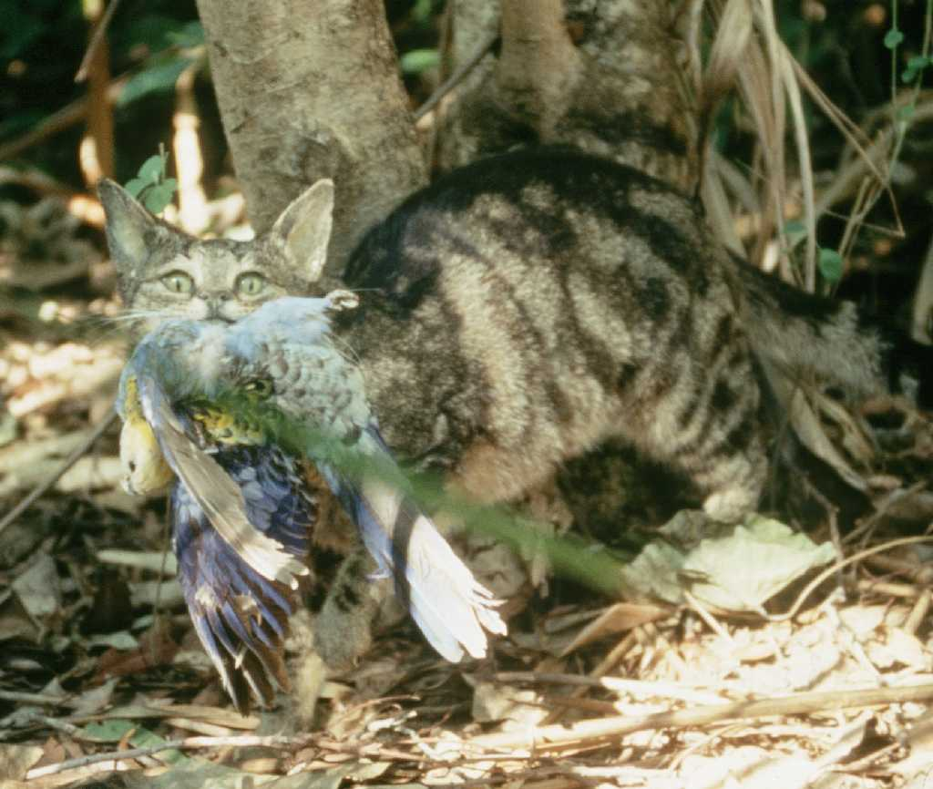

2. Dataset
The dataset consists of a training set and a test set. Datasets are loaded using load_from_disk, and are in the format of datasets. Test set is not visible to the contestants.
In the dataset there are the following fields:
- image: the image are RGB full color images in PIL format, the size of each image is (224, 224)
- name: the animal species label
- idx: unique identifiers used to track the records.
1.Training Set (train_dataset folder):
  - The training set is used for training your models/ doing experimentations on and can be accessed and downloaded directly during the competition.
  - There are 700 images in the training set.
2.Test Set (test_dataset folder):
  - These follow the same format as the training set but do not contain the name field.
  - There are 698 images in testing set, which had been separated into 2 testing sets within the ratio of 3:7, i.e. 30% of the data would be used to calculate the Leaderboard A score, another 70% data would be used to calculate the Leaderboard B score.
  - The testing set is used to calculate the Leaderboard A score and the Leaderboard B score and is not directly accessible during the competition. Contestants can access the result on Leaderboard A , but cannot access the result on Leaderboard B. The final score would be counted using Leaderboard B only. The subsets for Leaderboard A and Leaderboard B are completely distinct.

3. Task
You are given a dataset of animal photographs and a CLIP model that can do a zero-shot classification of animal species. To conserve bandwidth, you need to retain at most 6.25% of the pixels of each image, while keeping classification accuracy as high as possible.
More specifically, your task is to return one rectangle mask for each image, which contain a single rectangular area indicating the area to keep. Each mask is defined by two coordinate tuples: one for the top-left corner and one for the bottom-right corner of the rectangle. Below is a visualization of what the image would look like after applying a rectangular mask using the process from the baseline:
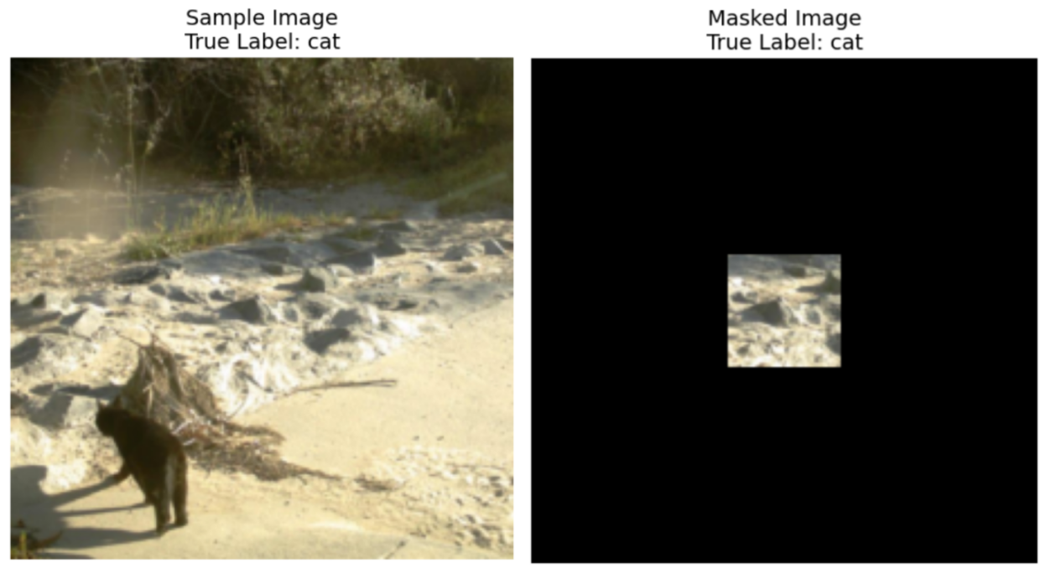
Coordinate Convention:
- Top-left corner coordinates are inclusive (the pixel at this position is included in the mask)
- Bottom-right corner coordinates are exclusive (the pixel at this position is NOT included in the mask)
For example, if you specify coordinates ((10, 20), (15, 25)), the mask will cover pixels from row 10 to 14 (inclusive) and column 20 to 24 (inclusive), for a total area of 25 pixels.
As an illustration, if an image size is 3x3 and we wanted to keep only the top-right pixel using coordinates ((0, 2), (1, 3)), the resulting binary mask would be:
[[0, 0, 1],
[0, 0, 0],
[0, 0, 0]]
Below is a summary of the requirements for your masks:
- Return one rectangle mask defined by coordinate tuples: ((top, left), (bottom, right))
- Top-left corner coordinates are inclusive, bottom-right corner coordinates are exclusive
- The rectangle mask should cover at most 6.25% of the original pixels (minimum 93.75% reduction of the original pixels)
- All images are of size (224, 224), so coordinate values should be within the range [0, 224]
Images would be masked using the mask you created, outside the masked rectangle, all pixels outside the masked rectangle will be replaced with RGB(0, 0, 0) (black) values. The masked image will be then passed through the CLIP model during evaluation, and your task is to keep the classification accuracy of the CLIP model on these masked images as high as possible. An additional other class would be added into the classes for classification to ensure that your masked image retains actual useful information for the researchers back at Starr Park Headquarters. So for example, if your image doesn't contain any animal information, the model will predict the others class instead of predicting a random animal and having a chance of getting it correct.
You need to work only with the provided CLIP model and dataset. As a reminder, CLIP generates representations for both text and image, and it can compute a similarity score between them. So if you have ten animal classes, CLIP can look at the provided image and decide which text (class) is closest to the image.
To ensure that your solution would handle the traffic of images for the research center, your code should run in UNDER 8 MINUTES for the 698 images in the test dataset. It is recommended that you test your solution on the training set first, which contain 700 images, to understand how much time your solution takes (testing set would take slightly longer due to dataset loading).

4. Submission
Contestants need to submit a notebook file named submission.ipynb. The file should output a .jsonl file titled submission.jsonl, which contains all the generated masks for the dataset split. Each mask in the submission.jsonl file should be stored as a tuple of two coordinate tuples: ((top, left), (bottom, right)), where the top-left corner is inclusive and the bottom-right corner is exclusive.
Contestants don't need to separate test sets into Leaderboard A and Leaderboard B, the evaluation machine will read submission.jsonl and automatically calculate the scores for Leaderboard A and Leaderboard B based on the prediction results and true labels.
The submission files must strictly follow the above format and naming; otherwise, the system will not be able to read them correctly.

5. Score
The evaluation metric will be classification accuracy, defined as the proportion of correctly predicted samples over the total number of evaluated samples.
Your score is the zero-shot classification accuracy of CLIP on the masked test images. If a submitted mask for an image is invalid (wrong shape, more than 6.25% pixels retained, etc.), that image is counted as incorrect. A sample script is provided to compute the training split score.

6. Baseline and Training Set
- The baseline is in baseline.ipynb.
- The training set is in training set.

7. Requirements
- Maximum submission limit: 15 times. Only successful submissions (i.e., those receive a score on Leaderboard A) will be counted toward the submission limit.
- Testing environment restrictions: The test machine will run your Notebook within 8 minutes. If the execution time exceeds 8 minutes, the system will forcibly terminate and return a feedback of “Timeout” or “Failed”.
- Data and model submission: In this task, participants can only submit a Notebook and cannot submit any mounted datasets or .pth files generated by themselves. Please check the upper right corner to remove the mounted dataset first.
- Network: For the on-site stage, the test machine cannot connect to the internet. In other words, downloading commands such as 'pip' and 'conda' or trying to call APIs will not work.
- Pretrained Model: The task provides a CLIP model in the dataset, you can find how to use it in baseline.ipynb. Any other pre-trained model can be used in this task when it can be imported properly without network connection and downloading. This message means the Bohrium cannot guarantee to exclude all the pretrained model in the Python image when installing the packages, when you find some useful ones, you can use them.

8. Precautions
- Which score is effective: Contestants can select up to 2 submission results for scoring (√ - selected， □ - not selected). The score before unification for this task will be determined by the higher score on the Leaderboard B among the two selected submissions. Other cases of score calculation: please refer to Appendix Platform Mechanisms and Restrictions for Individual Contest & GAITE.
- 
- How to deal with ambiguity: Once there is a conflict between the task description and the training set, the validation set and test set , the dataset will be respected first, and the dataset will not be changed during the competition.
- Contestants can only access Leaderboard A during the contest and cannot access Leaderboard B. The final score will be calculated only based on the score in Leaderboard B.
- The highest score by the Scientific Committee for this task is 0.83 in Leaderboard B, this score is used for score unification.
- The baseline score by the Scientific Committee for this task is 0.19 in Leaderboard B, this score is used for score unification.

<< FINAL PAGE >>

<< FINAL PAGE >>

